|  |
| --- |
| MEASURABLE RESULTS DELIVERED GLOBALLY |
|  |
| C:\Users\banswati\AppData\Local\Microsoft\Windows\INetCacheContent.Word\images.png  Collection Analytics  Project Charter  Prepared by: Subhasish Bera  June 9th 2017 |
|  |
|  |

TRUSTED · PROVEN · SCALABLE · INNOVATIVE · SECURE · ADAPTIVE · LOYAL

Table of Contents

Table of Contents 2

Background 3

Project Objective 4

Data Requirement 5

Our Approach 6

Timelines 8

Expectations and Assumptions 9

Project Team 10

Our Analytics Practice 11

Analytical Depth & Breadth Built on our Sutherland-Nuevora Global Analytics Platform 11

Embedded Analytics Offerings 14

Sutherland Overview 17

Background

NBADs’ current Credit Card collection process is categorized based an aging analysis i.e. based on the period elapsed since a payment fell due and is bucketized into – Bucket 1, Bucket 2 and Bucket 3. It has been observed that Service Delivery team can meet the target percentage collection in bucket 1 (which is 83%) where as in bucket 2 and 3 they are facing challenges. They are far behind the target i.e. 64% and 50% of total collection in bucket 2 and 3 respectively. The main objective of any collection analytics project is to segment the pool of delinquent customers in such a way that the segments are classified based on “difficulty of collection” and “propensity to pay”. The later being the main objective to optimize the absolute amount collected and the former to focus on “treatments”. Here “treatment” means soft reminder (say SMS), tele-calling, field visit, hard core collection, etc.

Our Proprietary Analytics driven Platform for BPO operations enables closed loop collection by integrating demographic, transaction and call center disposition data. The platform has a robust and an integrated suite of services covering from Diagnostics to Decision Support and from Predictive Scoring to Model Governance. We platform delivers value to the client by addressing the below:

Step 1: The Platform deploys predictive scores of every prospects and rank orders

Step 2: Decision engines help to deploy appropriate strategy for each segment at different score range

Step 3: Dialer or campaign manager triggers action by relevant channels

Step 4: Payment or Promise to pay are captured at agent level for each customer for feedback

Step 5: Model Manager incorporates the responses and recalibrate models on a batch process

The Analytics Engines based on machine learning techniques learns over time thus ensuring greater value to the client over a period of time. The Collection Analytics engagement will help NBAD to reduce flow forward of accounts and optimize cash flows.

Project Objective

Objective of this project is to analyze, prioritize and manage delinquent accounts and implement strategies to optimize collections while minimizing expenses. This will be achieved by Analytics Insights and Account level scores to predict propensity to pay so that overall collection goes up. It will enable the service delivery team to prioritize accounts for collection based on the Analytics suggested treatment strategies.

The overall objective of this exercise is to optimize the current collection efficiency. The specific objectives are:

1. To identify the accounts who have a higher propensity to pay
2. To suggest treatment strategies for targeting different segments based on complexity of collection
3. Modification strategies based on actual collection
4. Reporting model efficacy and tracking model performance over time

Data Requirement

Data Requirement document (DRD) will be shared with the NBAD team. We expect to receive a minimum of 2 years of data (as mentioned in DRD) preferably starting from May,2015 till May,2017. The table below mentions the list of data required and corresponding data owners.

|  |  |  |  |  |
| --- | --- | --- | --- | --- |
| Sl No# | **Data** | **Data type** | **Source** | |
|  |  |  | SGS SD | NBAD |
| 1 | Customer Data | Customer Demographic data |  | **√** |
| 2 | Invoice Data | Detailed information of invoices generated |  | **√** |
| 3 | Payment Data | Includes payment details for the invoices |  | **√** |
| 4 | Banking Information | Bank Account Details, Crédit Card details |  | **√** |

Data Request Document Shared with NBAD:



Our Approach

As this is a classification problem, we normally combine CHAID and Logistic regression to come up with the propensity to pay scores at the account level. Based on the data availability, the model is normally developed on a 70% sample and the validation is done on the remaining 30%. After validation the betas may or may not be smoothened depending on the model fit. We do validate the model by extreme validation techniques also. The steps that we follow include the below:

* Missing value and outlier treatment
* Optimal binning of the independent variables by CHAID before feeding in the model
* Univariate Logistic regression to identify the individual significant variables
* Multicollinearity check through VIF
* Model fit checking through concordance and Hosmer-Lemeshow criterion
* Estimated parameters used to score each accounts to find chances of payment

**Table 1: Some indicative variables to be considered for developing the model\***

|  |  |
| --- | --- |
| Variables used | |
| Business Unit | Ever in bucket 1 |
| Customer Industry | Ever in bucket 2 |
| Customer Group | No. of times month end bounces in first 3 months |
| Division Id | No. of times month end bounces in first 6 months |
| Transaction Class | No. of times month end bounces in last 3 months |
| Call Type | No. of times month end bounces in last 6 months |
| Call Attempts | No. of times in bucket 2 in first 3 months |
| Customer Region/State/Country | No. of times in bucket 2 in first 6 months |
| Invoice Cycle | No. of times in bucket 2 in last 3 months |
| Payment Terms | No. of times in bucket 2 in last 6 months |
| Customer Status (Active/Inactive) | Ever month end bounce in first 3 months (Y/N) |
| MOB (Customer Since) | Ever month end bounce in first 6 months (Y/N) |
| Outstanding Amount | Ever month end bounce in last 3 months (Y/N) |
|  | Ever month end bounce in last 6 months (Y/N) |

*The list is indicative and a comprehensive data fields with derived parameters would be discussed with NBAD stake holders before including in the final model*

**How the Collection Scorecard for NBAD Credit card would look like?**



* **Gradual decrease in Bad rates in higher score bands**
* **Target bottom scored 30% customers to capture 72% of Bads in the above example**

Bad: Customers will not pay by next month

Good: Customers will pay by next month

**Proposed Strategy**

The model is to be run to score all delinquent customers of different buckets at the month beginning and the strategy to prioritize the accounts will depend on the maximum separation of the ranked customers based on risk. The assumption is that we will predict monthly collection.



Timelines

Below are necessary milestones that we would follow during the project. Expected completion date will be subject to data receipt.

|  |  |  |
| --- | --- | --- |
| Milestone # | Tasks | Due on or before |
| 1 | Project Charter Sign off | TBD |
| 2 | Data Receipt | TBD |
| 3 | Data discovery - data audit/quality check | TBD |
| 4 | Model target definitions finalization with NBAD | TBD |
| 5 | Initial set up and development of Collection model on  Sutherland’s platform | TBD |
| 6 | Review of WIP solution for collection models & draft outputs  with NBAD (iteration #1) | TBD |
| 7 | Review of WIP solution for collection models & draft outputs  with NBAD (iteration #2) | TBD |
| 8 | Delivery of final Collection model, relevant insights and  required outputs (final & iteration #3) | TBD |
| 9 | Monthly scored file at the beginning of a month | Monthly |

Expectations and Assumptions

**Responsibilities of the Sutherland SD team**

1. To ensure the availability of project SPOC on a regular & as needed basis
2. Provide analytics team with all required data & documents
3. Validate & sign off on current program performance to measure Analytics impact
4. Should work with the analytics team to implement Analytics strategy
5. Attend weekly, monthly or any other planned meetings during the course of the project
6. Work with the analytics team for any project discussions & agreement

**Responsibilities of the Analytics team**

1. Provide the necessary data & analytics insights to improve NCR
2. Work internally with SD team to convert information generated to insights
3. Constantly strive to create value addition
4. Work with SD team to provide timely inputs
5. Work with the NBAD and SD team to improve collection strategy over a period of time
6. Help the team to integrate the strategies into GARMS

**Responsibilities of the NABD team**

NBAD to provide SGS Analytics team with all the required data as mentioned in the Data Requirement Document. Apart from making one-time data availability to build the models, NBAD is expected to provide monthly data for scoring purpose when the Analytics program goes live. NBAD team to mask any sensitive information and share it to SGS team for further analysis.

Project Team

|  |  |  |  |  |
| --- | --- | --- | --- | --- |
| **Project Team [Weekly Interactions]** | | | | |
| **Name** | **Department** | **Title** | **Role** | **Email** |
| Subhasish Bera | Analytics Delivery | Director | Analytics Insights Delivery | [subhasish.bera@sutherlandglobal.com](mailto:subhasish.bera@sutherlandglobal.com) |
| Swati Banerjee | Analytics Delivery | Sr. Analyst | Analytics Insights Delivery | [swati.banerjee@sutherlandglobal.com](mailto:swati.banerjee@sutherlandglobal.com) |
| TBD | Service Delivery | Manager | SD | [TBD](mailto:alejandro.manlincon@sutherlandglobal.com) |
| TBD | NBAD | TBD | TBD | TBD |
| **Project Escalation Team (Team Analytics)** | | | |  |
| Subhra Datta | Analytics | AVP | Analytics Delivery | [Subhra.datta@sutherlandglobal.com](mailto:Subhra.datta@sutherlandglobal.com) |
| Phani Nagarjuna | Analytics | VP | Analytics Delivery | [Phani.Nagarjuna@sutherlandglobal.com](mailto:Phani.Nagarjuna@sutherlandglobal.com) |
| Executive Steering Committee [Quarterly Review Internal to Sutherland] | | | | |
| Sumit Malhotra | SD | SVP | Executive Sponsor | [Sumit.Malhotra@SUTHERLANDGLOBAL.COM](mailto:Sumit.Malhotra@SUTHERLANDGLOBAL.COM) |
| Phani Nagarjuna | Analytics | SVP | Executive Sponsor | [Phani.Nagarjuna@sutherlandglobal.com](mailto:Phani.Nagarjuna@sutherlandglobal.com) |

Our Analytics Practice

Analytical Depth & Breadth Built on our Sutherland-Nuevora Global Analytics Platform

In 2016, Sutherland acquired leading global Analytics Service Provider - Nuevora. Through Analytics powered by our Sutherland-Nuevora platform, Sutherland is uniquely qualified to partner with NBAD on the data analytics initiatives and will bring a “best-practices” approach to our relationship via a unique global delivery model of People, Platform, and Proprietary Data. Sutherland’s advanced analytics, data processing, reporting/dash boarding and technology expertise enables it to deliver cutting edge insights driven by tailored models/algorithms that optimize return on marketing, customer experience/engagement, acquisition, retention, collection and profitability.

Sutherland-Nuevora Analytics platform focuses on big data and analytics from the perspective of the analytic life cycle; that is, it helps companies bring together data and process, visualize and model the data to reach a ***specific business outcome***.  It has ***established patterns of data processing and prebuilt predictive analytics apps*** that are based on best practices and designed to solve specific problems within industry segments.

With Sutherland-Nuevora big data platform, Sutherland now plays at the ***intersection of analytics, big data, and cloud***. Leveraging a powerful platform, Sutherland delivers scalable and repeatable analytics to organizations at rapid speeds. The platform, ***with its pre-built set of applications, brings in 60 to 70 percent automation for analytics*** delivery, with the last mile configuration and contextualization delivered by data scientists.

This approach for delivering analytics provides significant speed, scalability, and reliability while enabling closed-loop recalibration capabilities as required by the changing business circumstances and data dynamics of a given business. Further, Sutherland Analytics ***unified algorithmic architecture enables marketing organizations to gain an integrated and predictive view into all stages of a customer lifecycle*** (retention, up-sell, cross-sell,collection, profitability, LTV) in one glance; this is a big differentiator compared to a number of isolated solution providers.

Sutherland-Nuevora Analytics Platform solves the three problems of monetizing big data -Complexity, Consumerization and Continuity; and addresses these core issues by a customized solution that we propose to build for NBAD.

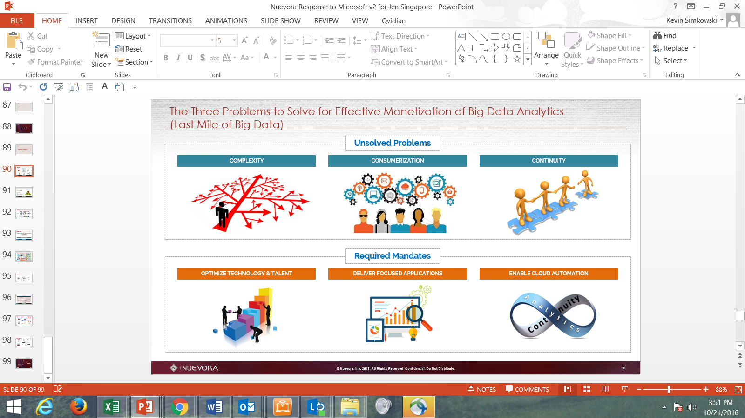

Sutherland Analytics Big Data philosophy shapes the way we approach Big Data Analytics and shapes our platform. This proposed solution could drive core value and differentiation for NBAD as you seek to gain deeper insights and analytic views to optimize your business results.

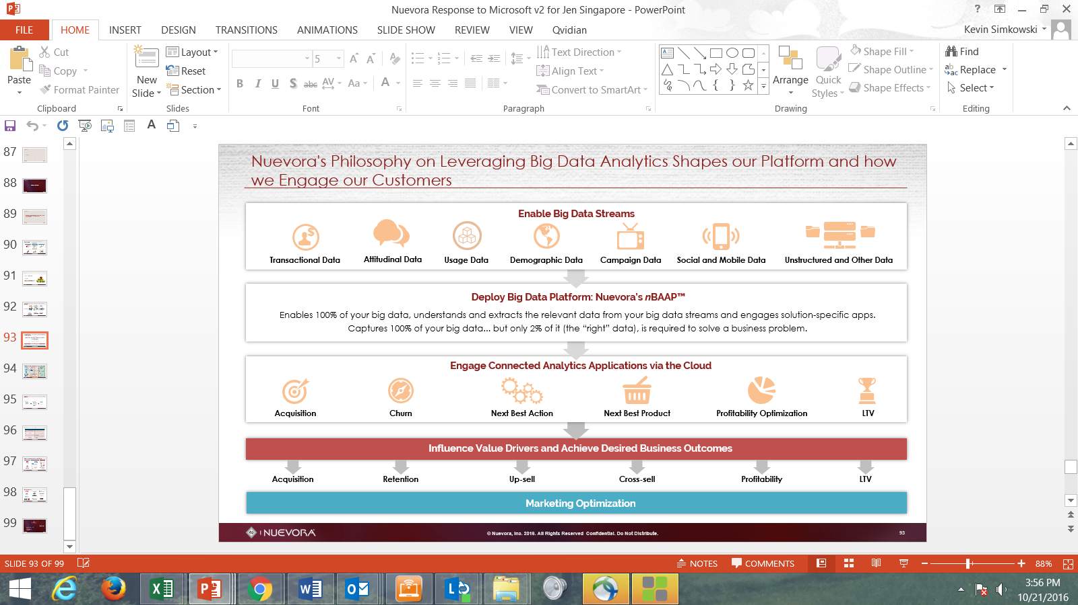

Sutherland is uniquely qualified to partner with NBAD having rich experience in scaled up Analytics implementation across multiple domain that include BFSI, Healthcare, Telecom, Technology and Travel. Our 100+ Analysts have deep experience in Big data, machine learning and deep learning techniques that they have been applying to solve problems in predictive modelling, text mining and social media analytics among others. Some of the case studies that might be of particular interest to NBAD are depicted below:

Selected case studies:

| Client | Problem/Solution Overview | Delivery Snapshot |
| --- | --- | --- |
| A Middle East Telecom Major | * Drive collections performance by risk ranking customers based on their Payment propensity * Use the results to optimize outbound effort to increase ROI | * Statistical model developed and deployed 3 months ago * Model Scores, monthly targeting strategy and score variation month on month can be tracked * High cost communication channels be offset by lower cost channels for lower risk segments * Work is underway to automate the scoring process to reduce monthly TAT of scoring |
| UK division operations of a Global Logistics Major | * Drive collections for B2B business for which Customs Duty is paid by the courier company on international inbound couriers, which later is recovered from the courier recipient against monthly ledgers | * Statistical model deployed and integrated with CRM * Monthly collections % increased by approx. 5% points owing to improved rank ordering of outstanding accounts (moving away from Outstanding amount to payment propensity scores) * Program approaching phase 2 for revisiting scoring algorithm and also the targeting strategy |
| A U.S. Healthcare Provider | * Optimize collections by prioritizing agent worklist based on payment propensity using Invoice data, Transactions and Payer data | * Statistical model deployed * Baselining completed * Implementation with CRM underway * Scoring is monthly but has been successfully automated |
| A Furniture and Electronics Rent to Own company in US | * Optimize collections efforts for monthly rentals for Furniture and Electronics sold to customers on Monthly collectible model. Agreement Amount, Agreement Term, Monthly payment expected vary from Account to Account | * Statistical models developed. Separate models for different delinquency buckets were developed * Targeting Strategy finalization and integration with CRM underway * Program is aimed at reducing the flow-forward from bucket 1 to higher buckets and clear off higher buckets outstanding |

Sutherland Overview

A global Business Process Outsourcing (BPO) and IT-enabled services company, Sutherland Global Services offers an integrated set of front and back office services that support the entire customer lifecycle. By combining highly trained people with state-of-the-art technology and proven business methodologies, Sutherland collaborates with clients to help them excel in their industries while maximizing their customers’ lifetime value.

Since our beginning, we have remained focused on a single mission: “to help improve our clients’ efficiency and productivity while delivering measurable results.” Our team works along the customer lifecycle continuum, identifying prospects on a client’s behalf, helping those prospects convert into customers, retaining those customer relationships, and providing back office services to maintain and grow those customers.

As one of the largest BPOs in the industry, we offer a balanced portfolio of services:

* **Business Transformation Services -** Process Consulting, Business Solutions, Platform Development and Global Transition
* **Business Process Outsourcing -** Technology Support, Customer Care, and Account Management
* **Information Technology Enabled Services -** Industry Specific Back Office Processing & Corporate Services (F&A, HRO, Employee Support, & Enterprise Help Desk)

These services operate across the entire lifecycle of our clients’ customers and touch the revenue side and cost/expense side of our clients’ P&L. To flawlessly execute this strategy and provide optimum results, we combine these offerings in a manner referred to as *integrated BPO*. The motivation is not just in reducing cost, but in driving clients’ business performance improvement.

Our annual growth rate is over 30% with 65% of our clients coming from the Fortune 500 space. Our services are provided by over 40,000 global employees across a variety of verticals.

Headquartered in Rochester, New York, we operate our delivery centers in more than 18 countries. Selection of geographies is based on three key attributes:

1. The availability of a scalable pool of high-end talent
2. Robust infrastructure
3. An economically and politically stable climate with a business-friendly environment

Contributing to our success are well-honed processes and custom technology frameworks. All of the provided services are platform-based. Our focus is on effective utilization of technological innovations through the products that we have built in-house, which in turn, help successfully drive efficiency and productivity.

Sutherland has a single-minded focus on helping our clients improve efficiency and productivity with measurable results spanning the entire lifecycle of their customers. Sutherland delivers business performance improvement, not just business process improvement.

Sutherland Facts

|  |  |
| --- | --- |
| Industry: | Business Process Outsourcing |
| Ownership: | Private |
| Year Founded: | 1986 |
| Headquarters: | Rochester, New York |
| Number of Clients: | 250+ |
| Number or Programs: | 2,000+ |
| Number of Employees: | 40,000+ |
| Quality Standards: | ISO 27001:2000, Six Sigma, PCI, P-CMM, Continuous Improvement, COPC ISO 9001:2000 |
| Industries Served: | Travel & Hospitality; Mortgage; Retail & e-Retail; Technology; Telecommunication, Wireless, Cable & High-Speed Internet; Insurance, Banking, & Financial Services; Healthcare; Government |

Global Footprint

Sutherland has created a network of key locations to help our clients meet their quality, language, and financial goals. Our combination of countries and selected sites has earned us the reputation of quality, scalable provider and as the local employer-of-choice. Our sites partner with local governmental and educational institutions to help prepare a skilled workforce of the future.

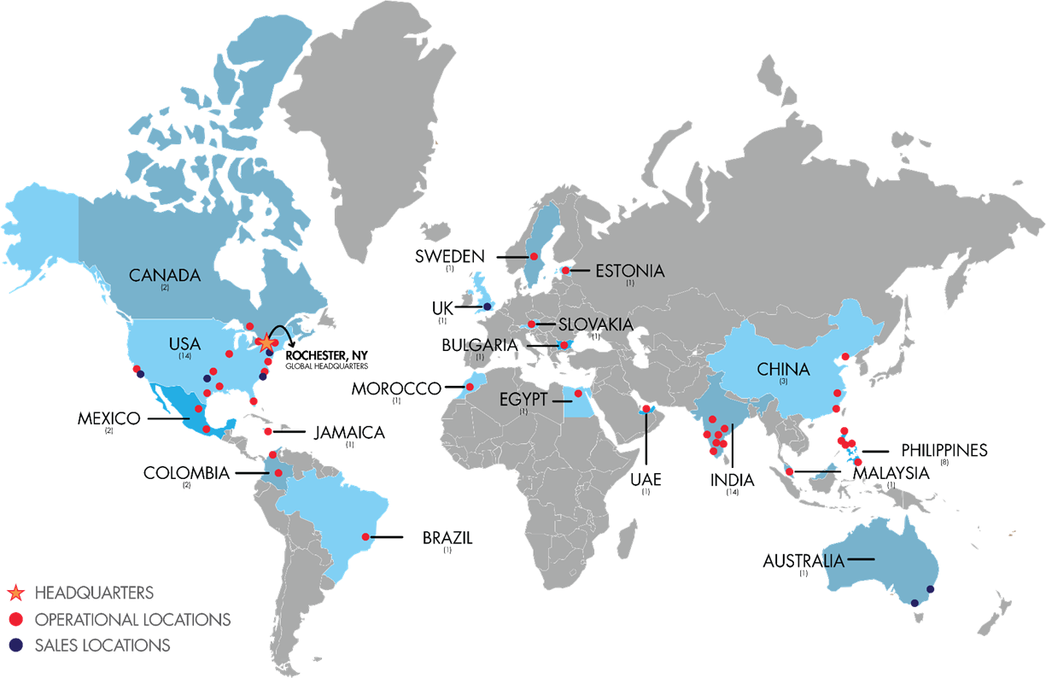

Key Differentiators

|  |  |
| --- | --- |
| Integrated BPO: Integrated BPO (I-BPO) is an end-to-end business-cycle solution that combines our service offerings, proprietary technology, and advanced analytics to consistently deliver measurable results directly impacting our clients’ business performance. | * 95% of our clients take advantage of two or more unique service offerings * 8 of our clients have more than ten service deployments * 38% of our clients are serviced out of more than one geography * More than 13 million customer transactions are processed per month |
| **Innovative Technology**: Sutherland services are proprietary technology-enabled and platform-based to ensure service delivery predictability, scalability, and repeatability. | * 361 available proprietary applications * 160 proprietary applications used for more than one client or facility |
| **Operational Analytics**: Deployment of advanced analytics to derive insights that accelerate and exponentially impact service cost reduction, revenue growth, and C-SAT enhancement. | * Deployment of advanced analytics to derive insights that accelerate and impact service cost reduction, revenue growth, and C-SAT enhancement |
| **Client Retention** | * Sutherland has a 96% client retention rate with 80% of our revenues derived from five-year (or longer) relationships. |

Awards & Recognition

For the past five years, we have steadily gained recognition among industry analysts and our clients for flawless execution, flexibility, and deep domain expertise. The following is a sample:

|  |  |
| --- | --- |
|  | IAOP Global 100 Service Providers: **Best Leader** – Revenue Growth, **Best Leader** – Number of Employees (2015) |
|  | FlexJobs 100 Top Companies with Remote Jobs (2015, 2016) |
| cid:image002.jpg@01CFF35D.8235B660 | Horses For Sources’ Robotics Premier League for BPO (2014: #1, 2015: #4) |
|  | International Business Awards Stevie Award Winner, Corporate Social Responsibility Program of the Year (2014: Bronze, 2015: Silver) |
| http://www.astd.org/~/media/Images/Awards/ASTD%20Awards%202014/BEST_4c_glow.jpg?h=179&&w=150&la=en | Association for Talent Development  BEST Award; Learning and Development Processes (2014) |
| http://www.bbb.org/globalassets/local-bbbs/houston-tx-148/media/apply-for-accred/accred_bus_7469-under-50k.jpg | Better Business Bureau Award for Excellence, Winner of Distinction (2014) |
| Global Outsourcing 100 Top Leader 2011 | Trade & Industry Development: Corporate Investment and Community Impact (CiCi) Award |
| CIO | Best CIO Awards: Thought Leaders for Leadership & Innovation “Leveraging IT for Business Performance” |
|  | Seven years on Inc. 5000 List of the Fastest-Growing Private Companies in America |
| http://www.sutherlandglobal.com/images/award_week500.gif | Information Week 500: One of the Top 500 Companies |
| BPO Excellence | BPO Excellence Award: BPO Organization of the Year and the Operational Excellence and Quality Award |
| http://singaporeblog.y-axis.com/wp-content/uploads/2012/03/frost-and-sullivan-logo.jpg | Frost & Sullivan: Global Integrated BPO Services Customer Value Leadership of the Year Award; Frost & Sullivan’s 2014 Mexican Growth Excellence Leadership Award in the Contact Center Outsourcing Services Industry |
| http://www.sutherlandglobal.com/images/award_risingstar.gif | Service & Support Professionals Association: Rising Star Award for Service Excellence |
| Best Service & Transaction Process Improvement Project | IQPC Lean Six Sigma & Process Improvement Summit: Best Service & Transaction Process Improvement Project |
|  | CenterState Corporation for Economic Opportunity Business of the Year (2015) |
|  | ISG Top 10 Outsourcing Service Provider (2015) |
|  | Talent Board North American Candidate Experience Award (2014, 2015) |